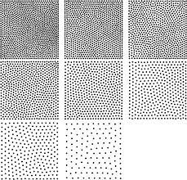
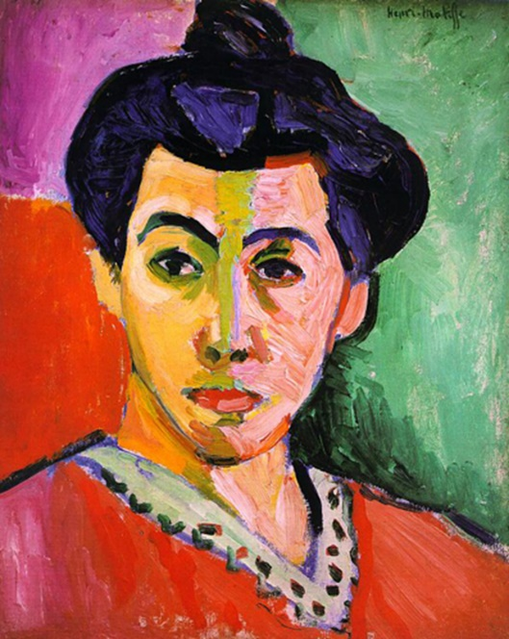
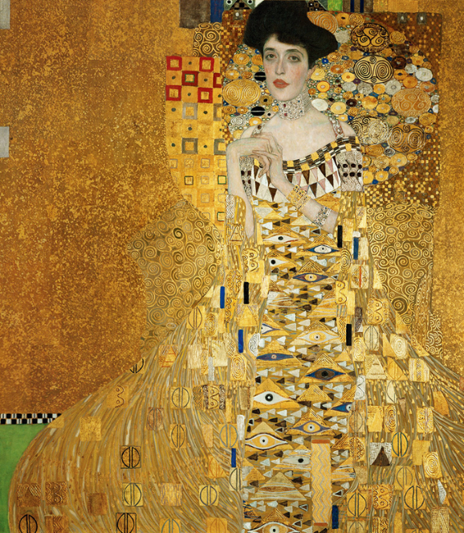
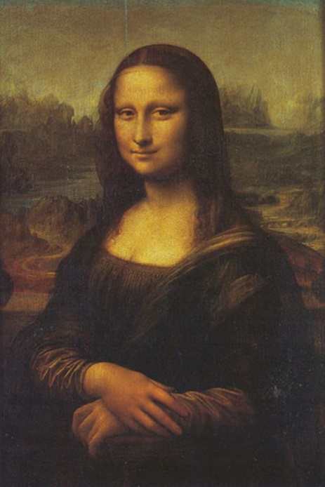
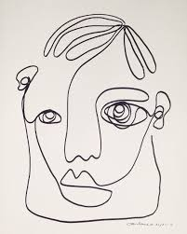
Key Vocabulary

portrait – a piece of art showing a person
self-portrait – a portrait that the artist has done of themselves
facial features – face, shoulders, head, eyes, nose, mouth, ears, hair, mouth

Artist
Leonardo da Vinci
The Mona Lisa

Artist
Gustav Klimt
Adele Block-Bauer

Artist
Henri Matisse
Madame Matisse

stippling

continuous line

Key Skills:
- Sketching - a rough or unfinished drawing
- Continuous line - an unbroken line from beginning to end to develop an image
- Stippling - the process of drawing numerous small dots to simulate different degrees of solidity or shading in a drawing

Year 1 - Autumn 1 – Art Knowledge Organiser – Drawing (Pencil Sketch) - Portraits

