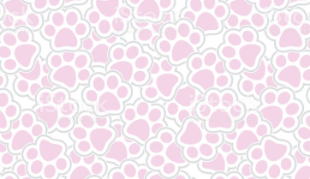
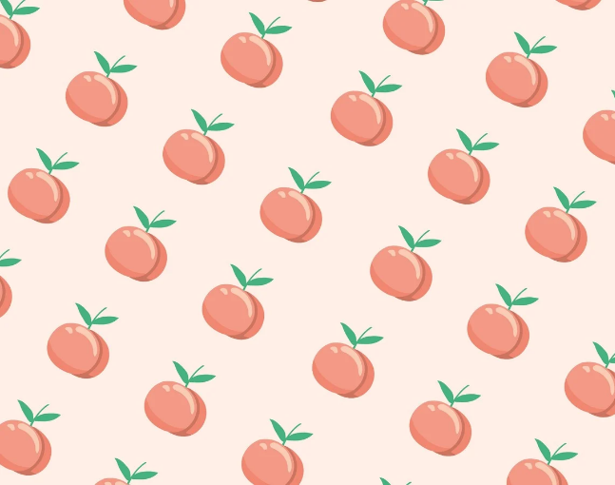
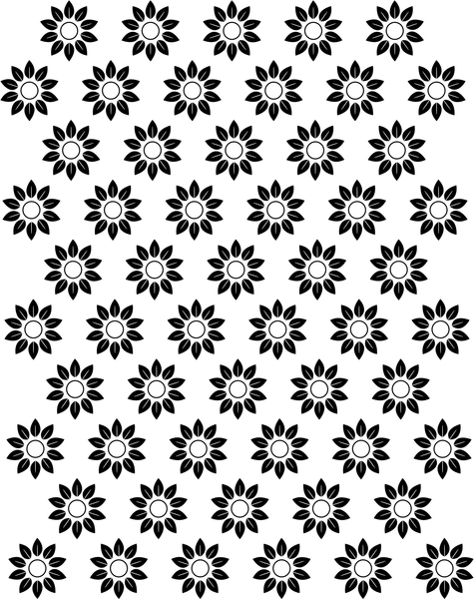
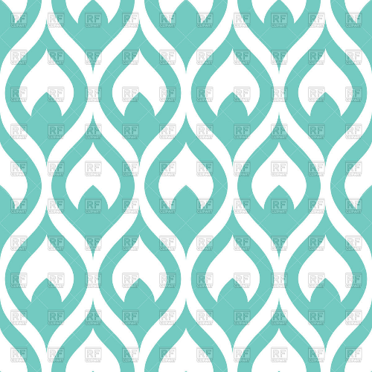
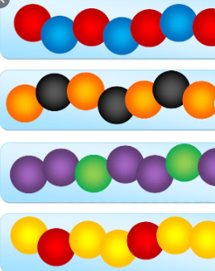
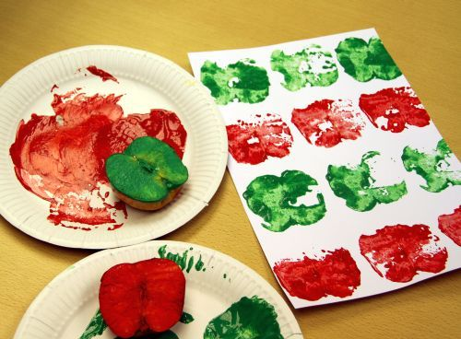
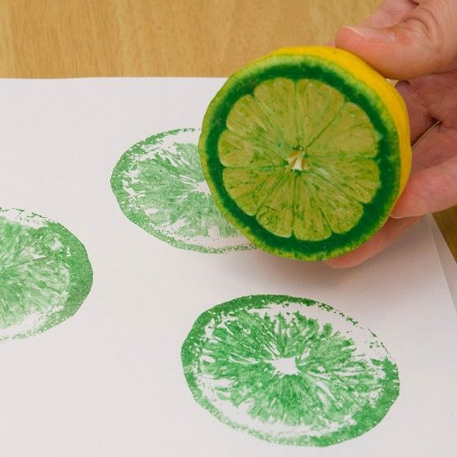
patterns

press printing

Key Skills:
- Pattern design – to create your own pattern
- Press printing – to transfer paint from one surface to another by pressing them together

Key Vocabulary

print – to transfer a picture from one surface to another
surface – the top layer of something
texture – how something feels
pattern – something that is repeated over and over

Year 1 - Autumn 2 – Art Knowledge Organiser – Printing

