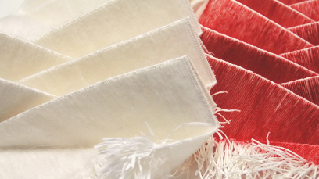

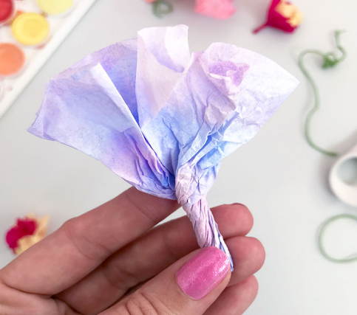
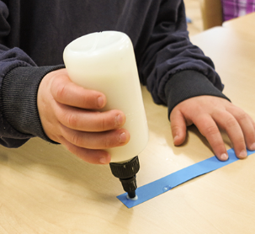
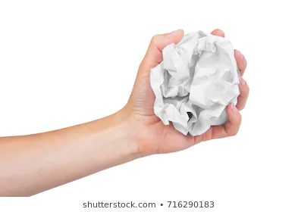
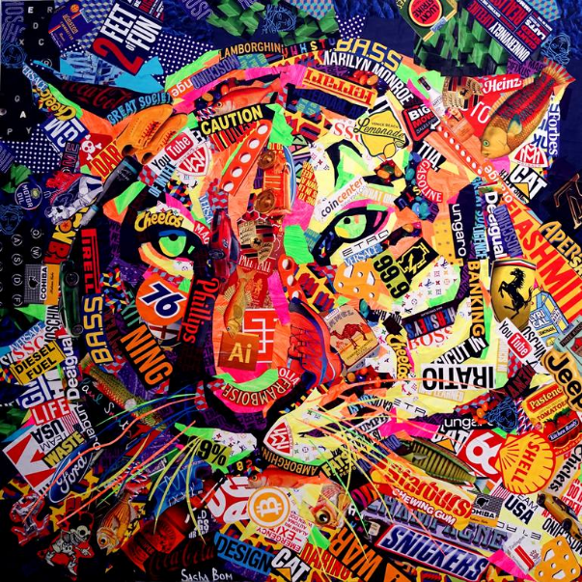


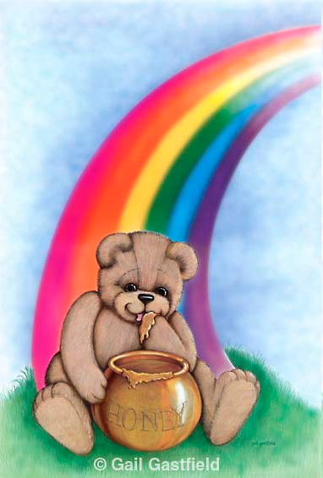
manipulating materials

examples of collages

Key Skills:
- Collage – manipulate materials in different ways – i.e scrunch, twist, fold, stick, cut

Key Vocabulary

collage – a piece of art made by sticking different materials to a surface
material – the thing from which something is made

Artist
Gail Gatsfield
Teddy Bear’s Pot of Gold
(Stimulus for collage)

Year 1 - Spring 1 – Art Knowledge Organiser – Collage
stippling

