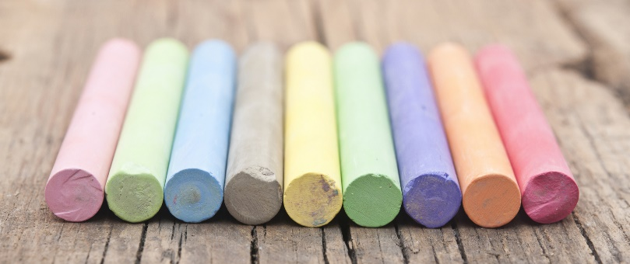
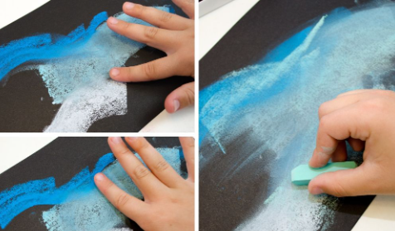
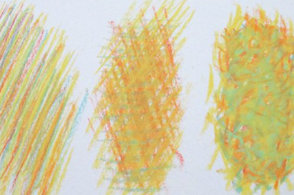
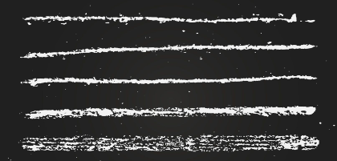
chalk

feathering

line thickness

blending

Key Skills:
- Blend – to smear and combine different coloured chalks together
- Feather – to apply chalk to a surface using lines that cross or overlap each other
- Pressure – to apply chalk using varying pressures – hard and gentle
- Line thickness – to apply chalk using the side to create thick lines, and the end to create thin lines

Key Vocabulary

blend – to mix or combine something together
hard (pressure) – to use lots of force
gentle (pressure) – to use little force
thick – sides that are far apart
thin – sides that are close together

Year 1 - Spring 2 – Art Knowledge Organiser – Drawing (Chalk)

