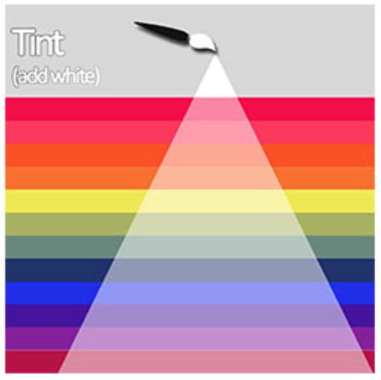
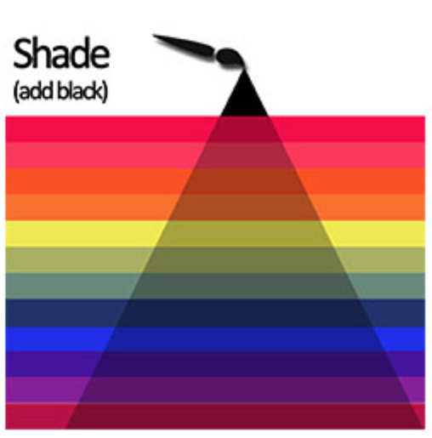
Key Skills:
- Colour mixing – to add white to colour to tint
- Colour mixing – to add black to colour to shade
- Colour matching – to select and mix colours to match the colour of existing objects or pictures
- Paintbrush skills – to know how to hold a paintbrush

Key Vocabulary

pattern – something that is repeated over and over
texture – how something feels
mix – combine something together
tint – to add white to a colour to make it lighter
shade – to add black to a colour to make it darker
match – to make something equal, the same

Year 1 - Summer 1 – Art Knowledge Organiser – Painting

