Year 1 - Spring – Geography Knowledge Organiser – Weather Around the World

Key Vocabulary

weather – the state of the atmosphere – dry, hot, sunny, rainy, windy etc.
temperature – a measurement of heat, how hot or cold something is
North Pole – the point furthers North on Earth
South Pole – the point furthest South on Earth
Equator – an imaginary line drawn around the middle of the Earth
Earth – the planet where we live

Key Facts
- I know that it is cold at the North and South Poles
- I know that it is hot near the equator
- I can describe the weather in the United Kingdom

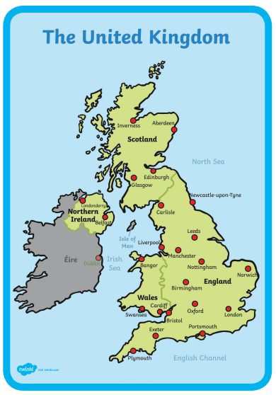
rain

sun

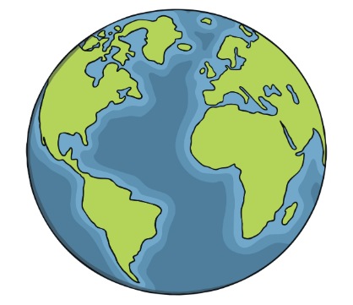
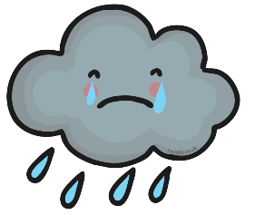

The South Pole

The Equator

The North Pole

snow

cloud

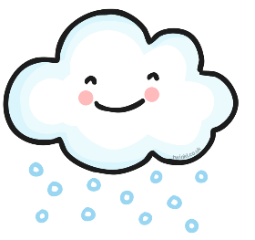


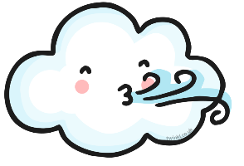
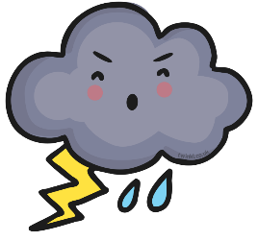
wind

storm

