Year 1 - Summer – Geography Knowledge Organiser – Map Skills/School and Local Area Study

Key Vocabulary

map – a drawing or picture that shows the location of things (where things are) from a bird’s eye or aerial view
bird’s eye/aerial view – the view from above, looking down
map symbol – a picture of shape on a map
key – an explanation of what symbols on a map mean
address – information about where a person or place is
compass – a tool for finding direction

Key Facts/Skills
- I know what a map is and can create my own
- I can name the four compass directions – North, South, East and West
- I know what a bird’s eye and aerial view are
- I know the first line of my home address

example of a bird’s eye view map with symbols and a key

compass
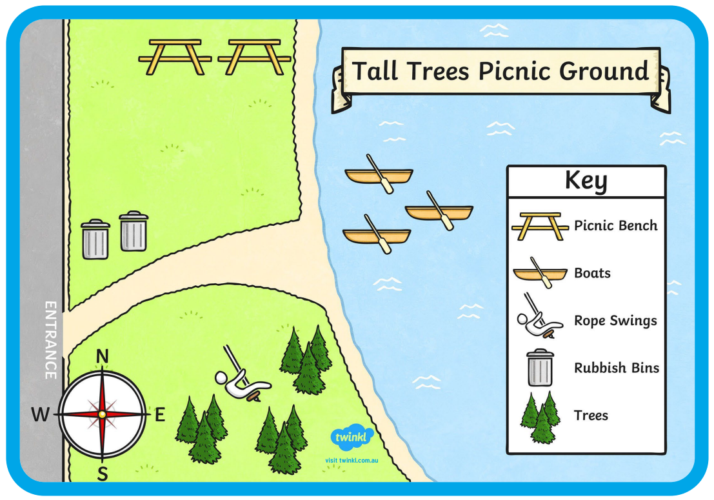

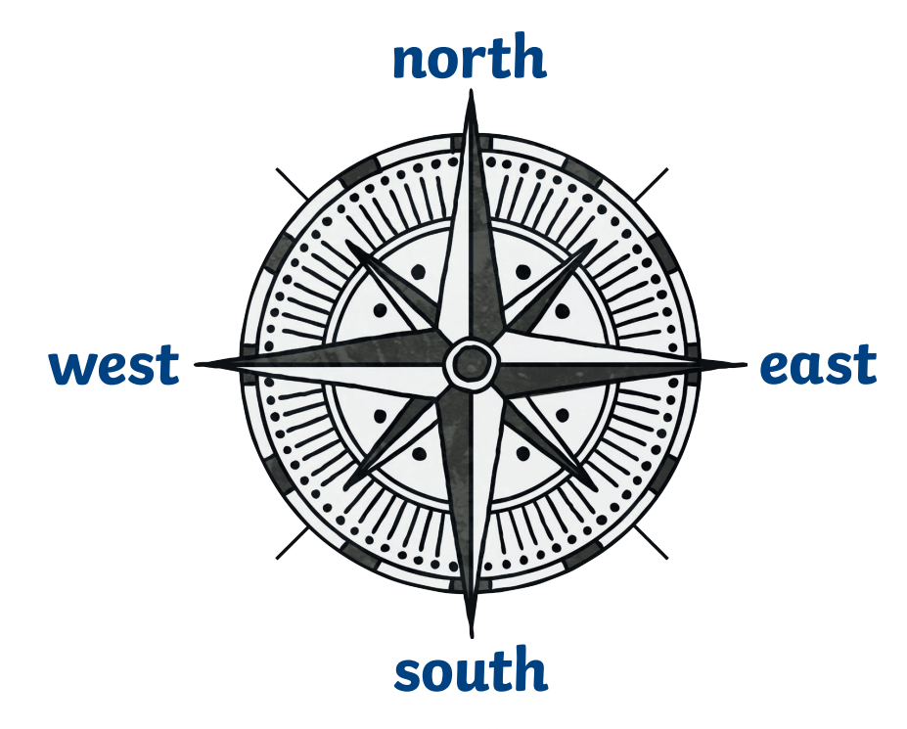

Key Vocabulary – types of houses

detached – a house that is separate to others
semi-detached – two houses that share a side wall that are separate to others
terraced – a long row of houses sharing side walls
bungalow – a house with no upstairs
flat/apartment – a set of rooms for living in, part of a larger building
cottage – a small, old house, usually in the country

Key Facts
- I can name some of the different types of houses that people live in
- I know that houses are a human feature of geography

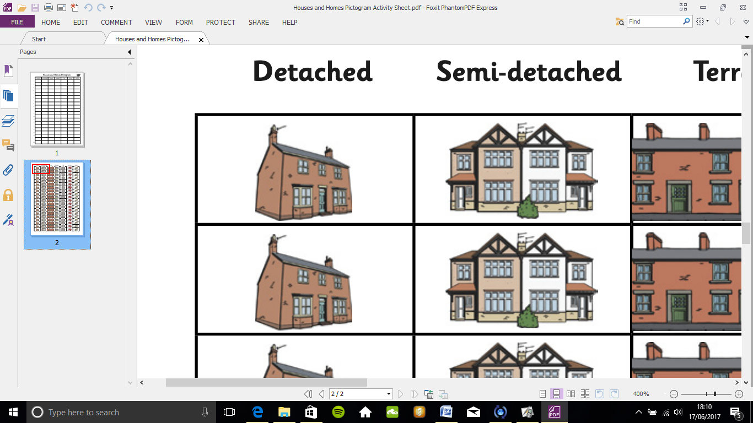
semi-detached
terraced
detached
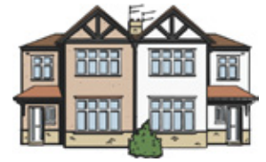
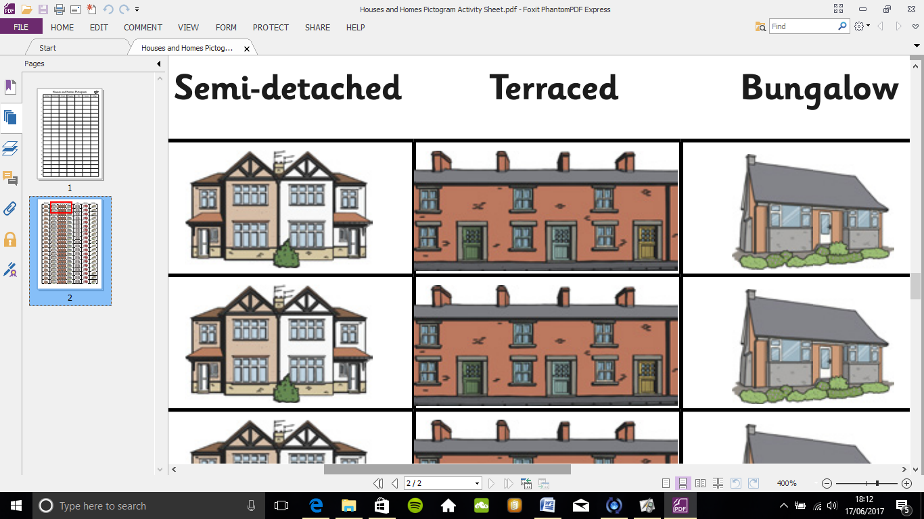
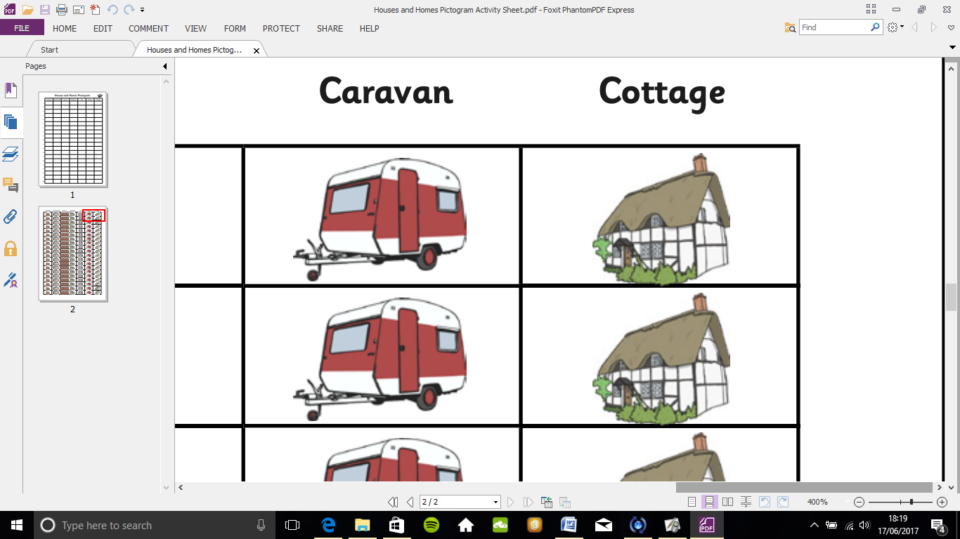
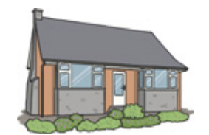
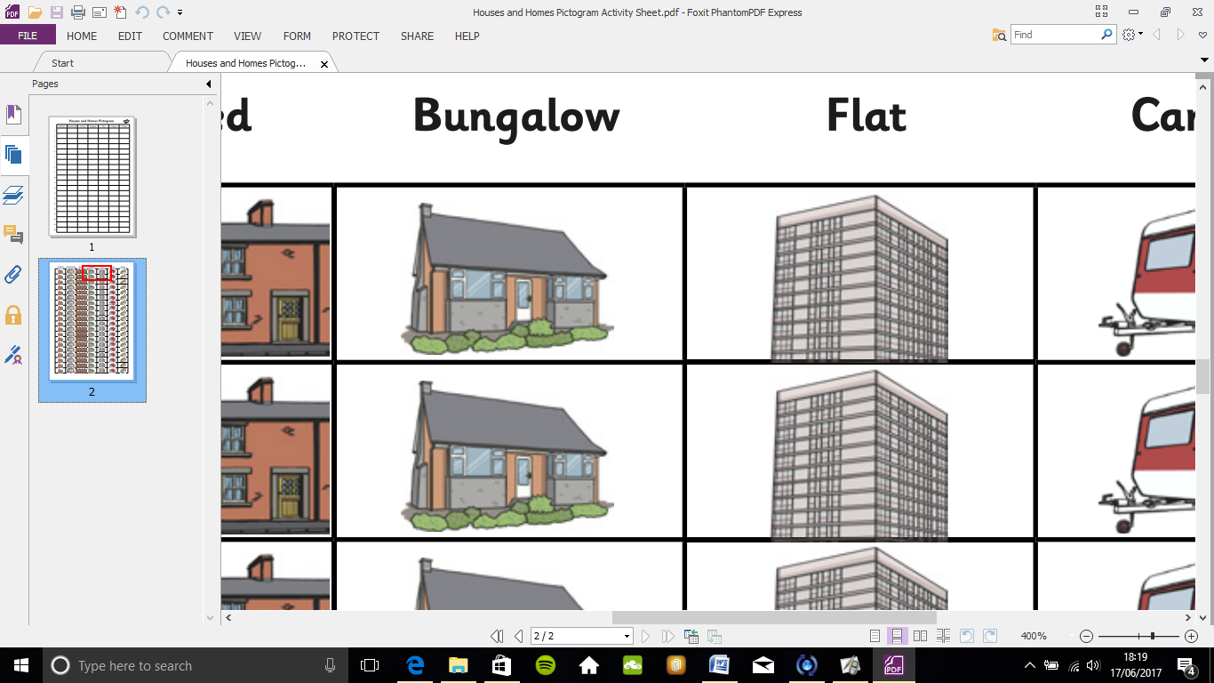

bungalow
cottage
flat/apartment

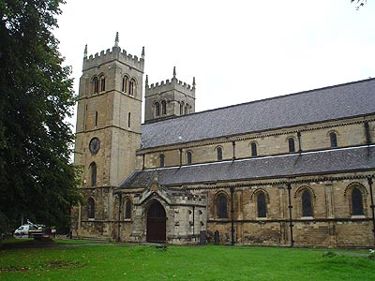
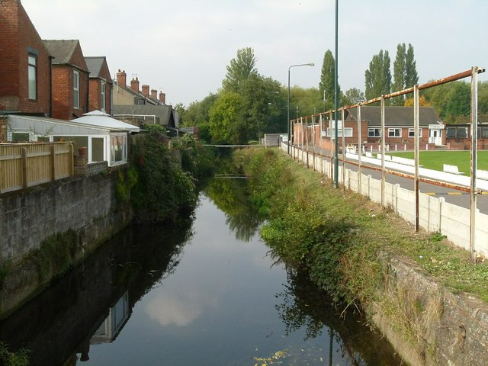
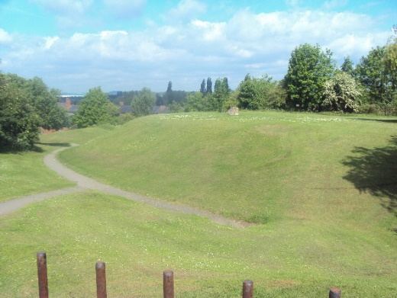
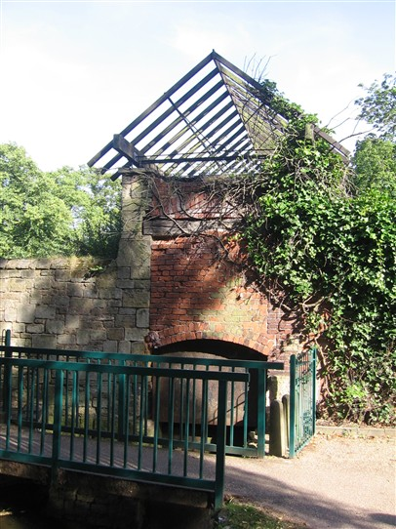
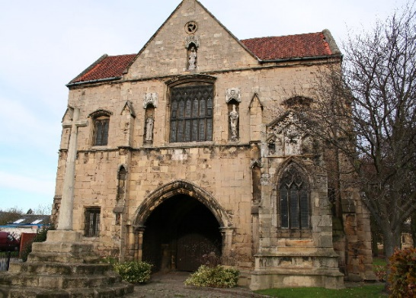
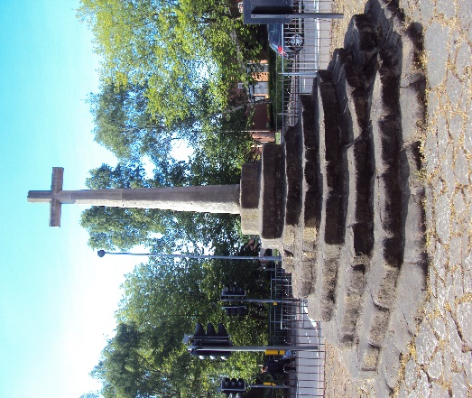
Key Vocabulary – our local area

local area – the area around where you live
physical features – things that occur naturally in nature – river, hill
human features = things that have been built by humans – church, mill

Key Facts
- I can name some physical and some human features of geography
- I know that the name of the town where we live is Worksop
The River Ryton
Worksop Priory Church
The Canch Mill
Castle Hill
The Market Cross
Worksop Priory Church

