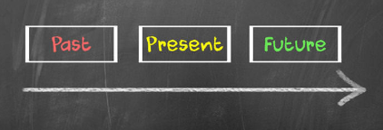
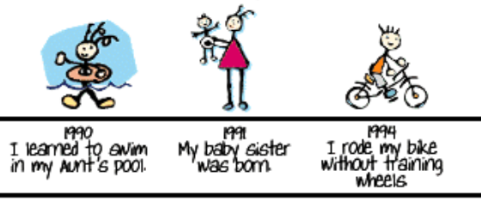
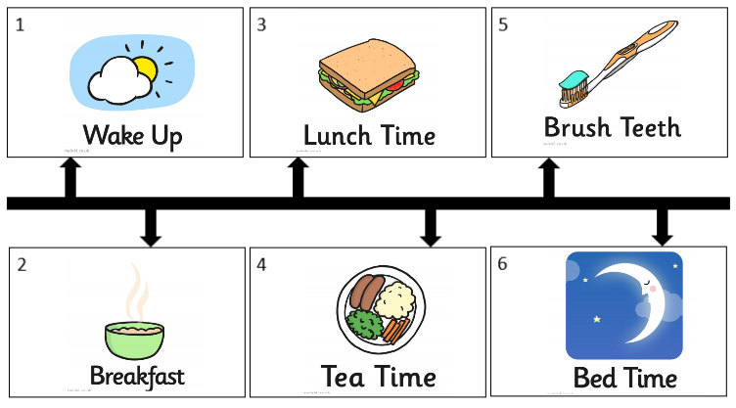
an example of daily events on a timeline

an example of personal life events on a timeline

Key Facts:
- I can talk about the past, present and future showing an awareness of the passage of time.
- I know what a timeline is.
- I can order daily events on a timeline.
- I can order personal life events on a timeline.

Key Vocabulary

present – a moment of time happening right now
past – anything that has happened before right now
future – anything that will happen after right now
old – something that has been around for a long time
new – something that has only been around for a short time
today – the present day
tomorrow – the day after the present one
yesterday – the day before the present one
timeline – a way of showing the order in which events happened

Year 1 – Autumn – History Knowledge Organiser – Personal History

