Year 1 - Spring – History Knowledge Organiser – Changes Within Living Memory - Toys

Key Facts – differences between old and new (modern) toys
- Old toys were often made of wood
- New (modern) toys are often made of plastic
- Old toys were mechanical or moved by hand
- New (modern) toys may use batteries of electric
- Old toys were usually made by hand
- New (modern) toys are usually made by machines


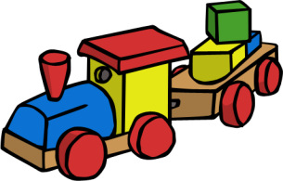
Key Vocabulary

present – a moment of time happening right now
past – anything that has happened before right now
future – anything that will happen after right now
old – something that has been around for a long time
new – something that has only been around for a short time
modern – something relating to the present time
timeline – a way of showing the order in which events happened
change – no longer the same, to make something different
Victorian – an era of history in the United Kingdom when Queen Victoria was on the throne – from 1837-1901

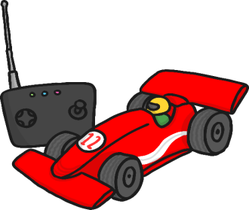
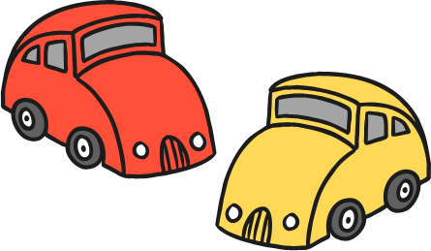

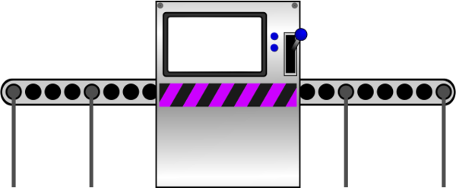
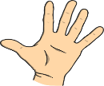

Key Facts – toys in Victorian times

In many homes the only toy children were allowed to play with on Sundays was a Noah’s Ark because it was related to the Bible.

Victorian children liked to play games outside such as football and hoop rolling.

Children from rich Victorian families played with toys such as rocking horses, toy soldiers and dolls.

Children from poor Victorian families played with toys such as wooden boats and peg dolls.

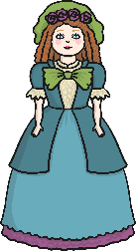
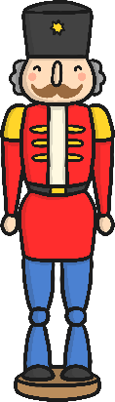
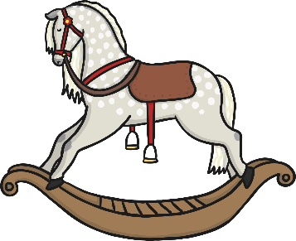
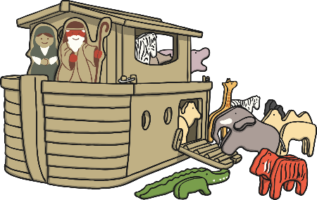

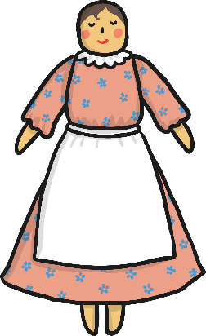
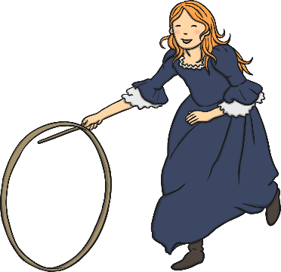
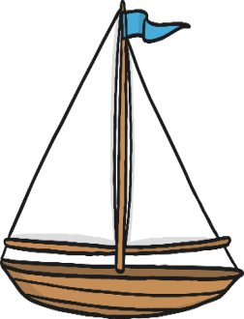
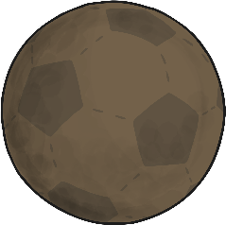
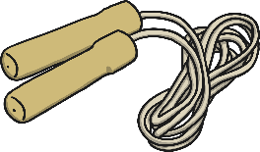

Toy Timeline



