
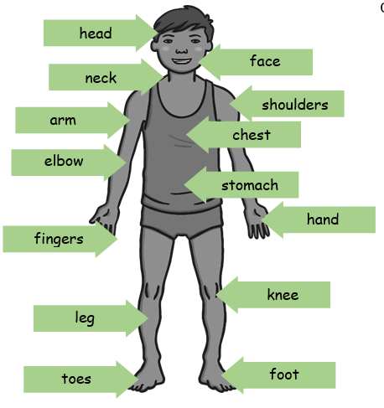
Year 1 - Autumn 1 - Science Knowledge Organiser - Animals including Humans
Key Facts:
- I can identify, name, draw and label different parts of my body.
- I can say which part of the body is associated with each sense.
- I know that I have 5 senses.
- I know I use my eyes to see.
- I know I use my ears to hear
- I know I use my nose to smell.
- I know I used my tongue to taste.
- I know I use my skin to touch.
Key Vocabulary – body parts

Key Vocabulary - senses

sense – our senses tell us about the world around us.
sight – the sense of being able to see.
hearing – the sense of being able to hear.
smell – the sense of being able to smell
taste – the sense of being able to taste.
touch – the sense of being able to touch.

