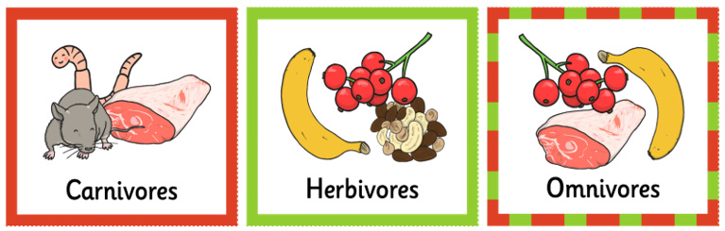
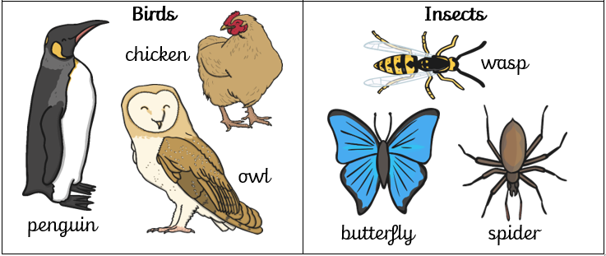
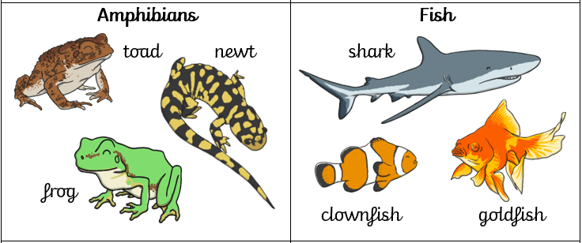
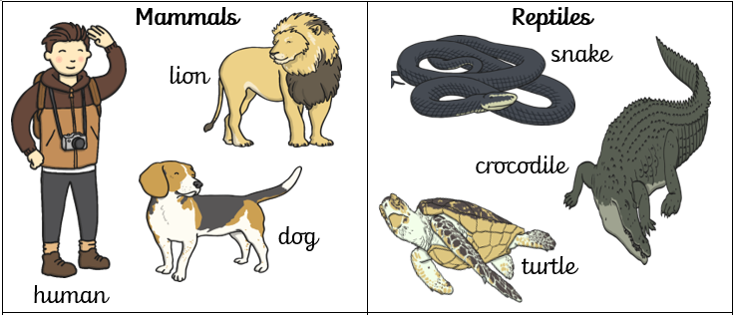
Key Facts:
- I can identify and name a variety of common animals.
- I know what diet a carnivore, herbivore and omnivore eats.
- I can give an example of a mammal, a reptile, an amphibian, a fish, a bird and an insect.

Key Vocabulary

diet – the food that you eat
carnivore – an animal that eats other animals.
herbivore – an animal that eats plants.
omnivore – an animal that eats other animals and plants.
mammal – an animal with fur or hair that give birth to live young
reptile – a cold blooded animal with scales
amphibian – an animal which is able to live in water and on land
fish – an animal that lives in water with fins and gills
bird – an animal with feathers and wings
insect – an animal with a three-part body and 6 legs

Year 1 - Autumn 2 - Science Knowledge Organiser - Animals including Humans

