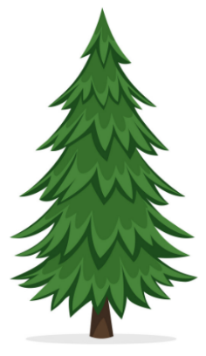
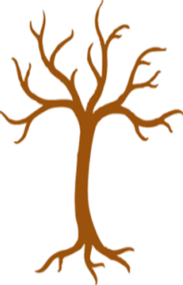
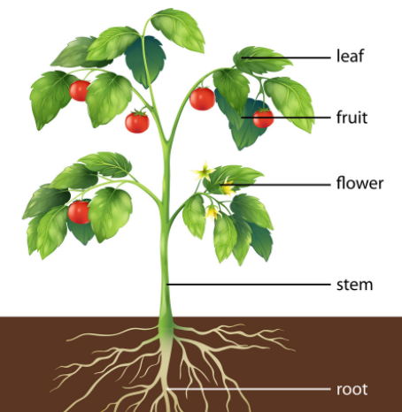
Deciduous trees lose their leaves in winter.
Evergreen trees do not lose their leaves in winter.
Key Vocabulary

flower – the part of a plant that blossoms and produces seeds
fruit – the part of a plant that contains the seeds
seed – develops in a fully grown plant
leaf – attached to the stem of a plant, takes in sunlight
stem – supports the leaves and flowers, carries water to the plant
root – holds a plant upright, takes in water from the soil
pollen – a powder made by plants, insects carry it from flower to flower
healthy – being well, not poorly or sick
light – the opposite of dark, made by the sun
water – the liquid that all living things need to survive
warmth – to have a warm temperature, the opposite of cold
nutrients – from food, help living things to grow and stay healthy

Key Facts:
- I can name the parts of a plant.
- I can name a variety of plants including trees, flowers, fruits and vegetables
- To stay healthy, a plant needs light, water, warmth and nutrients
Year 1 – Summer - Science Knowledge Organiser – Plants

Key Vocabulary

wild plant or weed – ta plant that doesn’t need to be cared for, the seed will grow wherever it lands
garden plant – a plant that is grown in a garden because it looks nice or can be eaten

wild plants

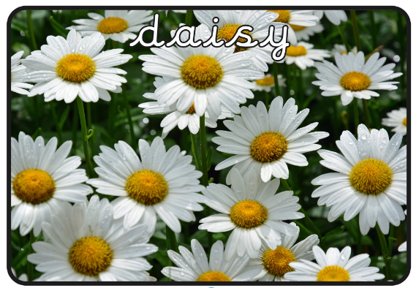
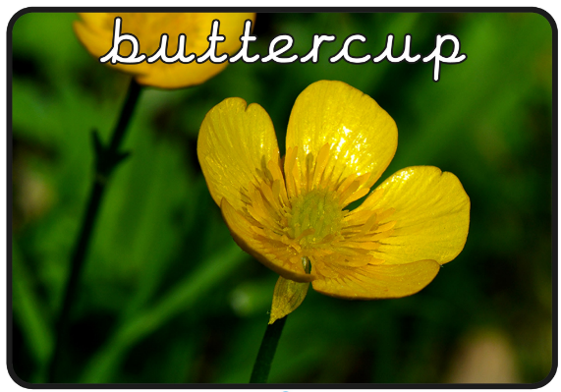
garden plants


