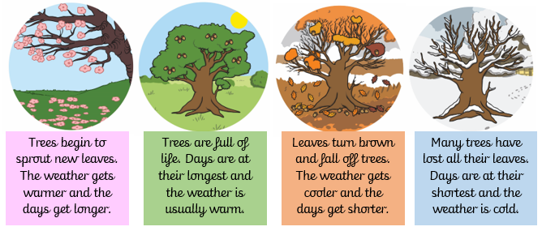
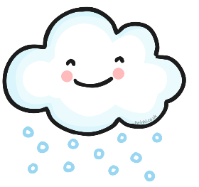
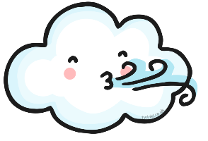
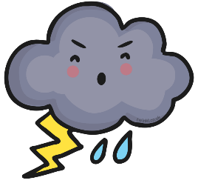
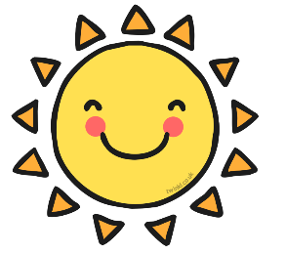
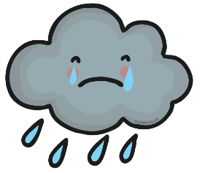

weather

Key Vocabulary

season – the four times of the year with distinct weather patterns and daylight hours
weather – the state of the atmosphere – dry, hot, sunny, rainy, windy etc.
temperature – a measurement of heat, how hot or cold something is
day length – the number of hours of daylight, the time from when the sun rises to when the sun sets

Key Facts:
- I can name the four seasons – Spring, Summer, Autumn, Winter
- I can describe weather, day length and other changes associated with each season
seasons of the year

Winter

Autumn

Summer

Spring

cloud

rain

sun

storm

wind

snow

Year 1 – Year Long - Science Knowledge Organiser – Seasons and Weather

